ELECTRICAL FEEDER CABLE SETASSEMBLY

- PARTS LIST:

QUANTITY: PART #: NOMENCLATURE:

2 PER CABLE (24 PER MACHINE SET) 17464-1 CONNECTOR SOCKET WITH RELIEF

1 PER CABLE (12 PER MACHINE SET) 19224-3 #24 AWG RIBBON CABLE

1 PER CABLE (3 PER MACHINE SET) 18776- KEYING PLUG

- RIBBON CABLE CUT LENGTH:

- CUT CABLES IN SETS PER MACHINE, ACCORDING TO LENGTH, AS FOLLOWS:

LENGTH: 21” LENGTH: 28”
QUANTITY: 4 QUANTITY: 4

LENGTH: 35” LENGTH: 37”
QUANTITY: 2 QUANTITY: 2

LENGTH: 24” (WITHOUT CONNECTORS)
QUANTITY: 3

CABLE #: LENGTH (“): CABLE #: LENGTH (“):

- 21” 7 21”

- 28” 8 28”

- 35” 9 35”

- 37” 10 37”

- 28” 11 28”

- 21” 12 21”

NOTE 1
WHEN USING PART # 19224-3 CABLE, ½” OF BOTH ENDS MUST BE PRESSED IN A VISE IN ORDER TO EXPAND THE CABLE WIDTH. THE CABLE IS NOT NORMALLY WIDE ENOUGH TO PROPERLY FIT INTO THE CONNECTOR (17464-1).

- CABLE ASSEMBLY:

- ASSEMBLE THE CABLES ACCORDING TO DIAGRAM 1.
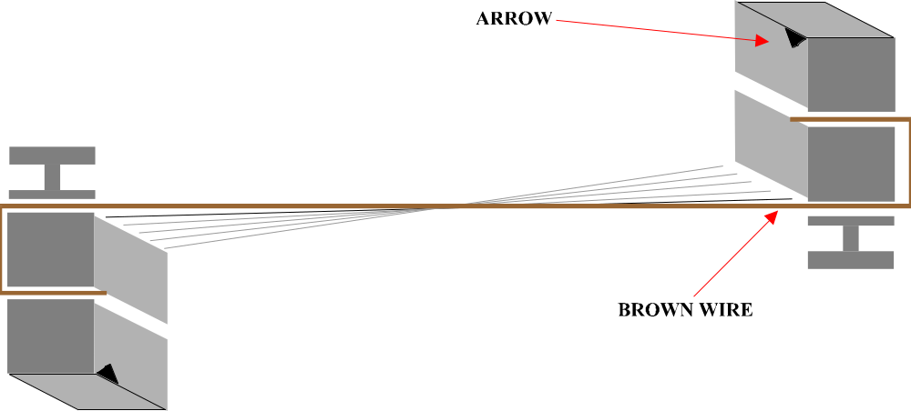

DIAGRAM 1

NOTE 2
THE BROWN WIRE MUST ALIGN WITH THE NOTCHED ARROW IN THE CONNECTOR BLOCK AS SHOWN IN DIAGRAM 1.

